7. SINIF TÜRKÇE DERSİ ÖZGÜN YAYINLARI KONU SORU DAĞILIMI TABLOSU

|  |  |  |  |  |  |
| --- | --- | --- | --- | --- | --- |
| P1398C1T7#yIS1 | P1400C2T7#yIS1 | P1404C3T7#yIS1 |  | | |
|  |  | |
| **1. Senaryo** | **2. Senaryo** |
| P1436C14T7#yIS1 | P1441C15T7#yIS1 |  |  |  |  |
|  | **\*** | **\*** | **\*** |
|  |  |  |  |
|  | **\*** | **\*** | **\*** |
|  | **\*** | **\*** | **\*** |
|  | **\*** | **\*** | **\*** |
|  | **\*** | **\*** | **\*** |
|  |  |  |  |
|  |  |  |  |
|  |  |  |  |
|  |  |  |  |
|  |  |  |  |
|  | **\*** | **\*** | **\*** |
|  |  |  |

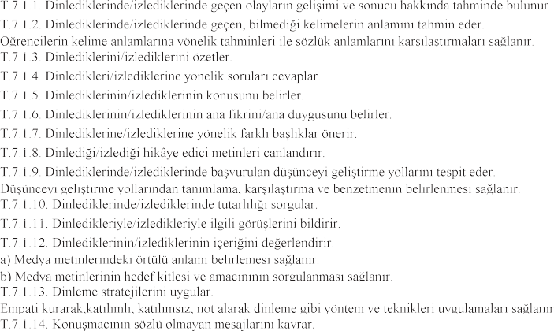

|  |  |  |  |  |  |
| --- | --- | --- | --- | --- | --- |
| P1583C1T8#yIS1 | P1585C2T8#yIS1 | P1587C3T8#yIS1 | **\*** | **\*** | **\*** |
|  | **\*** | **\*** | **\*** |
|  | **\*** | **\*** | **\*** |
|  |  |  |  |
|  |  |  |  |
|  |  |  |  |
|  |  |  |  |
|  |  |  |  |  |  |
| **T.7.3. OKUMA** | P1664C2T9#yIS1 |  | **\*** | **\*** | **\*** |
|  | **\*** | **\*** | **\*** |
|  |  |  |  |
|  |  |  |  |
| P1718C31T9#yIS1 |  | 2 | 1 | 1 |
|  | 1 | 1 |  |
|  |  |  |  |
|  | 1 |  | 1 |
|  | 2 | 1 | 1 |
|  | 1 |  |  |
| P1790C74T9#yIS1 |  |  |  |
|  | 2 | 1 | 1 |
| 1 |  |  |
|  |  |  |  |  |
|  |  |  |  |
|  | 1 | 1 |  |
|  | 1 | 1 |  |
|  | 1 |  |  |
|  | 1 | 1 | 1 |
|  |  |  |  |
|  | 1 |  | 1 |
| **T.7.3. OKUMA** |  | 1 | 1 | 1 |
|  | 1 |  |  |
|  |  |  |  |
|  |  |  |  |
| P1954C182T9#yIS1 |  |  |  |
|  |  |  |  |
|  | 1 |  |  |

|  |  |  |  |  |  |
| --- | --- | --- | --- | --- | --- |
| **T.7.3. OKUMA** |  |  | 1 |  |  |
|  |  |  |  |
|  |  |  |  |
|  |  |  |  |
|  |  |  |  |
|  |  |  |  |
|  |  |  |  |
|  | 1 | 1 | 1 |
|  |  | 1 | 1 |
|  |  |  |  |

|  |  |  |  |  |  |
| --- | --- | --- | --- | --- | --- |
|  | P2118C2T11#yIS1 |  |  |  |  |
|  |  |  |  |
|  |  |  |  |
|  | 1 |  |
|  |  |  |  |
| P2172C38T11#yIS1 |  |  |  |
| P2183C45T11#yIS1 |  |  |  |
| P2194C52T11#yIS1 |  |  |  |
|  |  |  |  |
|  |  |  |  |
|  |  |  |  |
|  |  |  |  |
|  |  |  |  |
|  |  |  |  |
|  |  |  |  |
|  |  |  |  |
|  |  |  |  |
|  | | | **20** | **11** | **9** |

