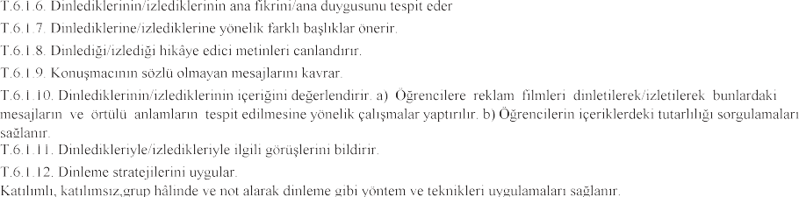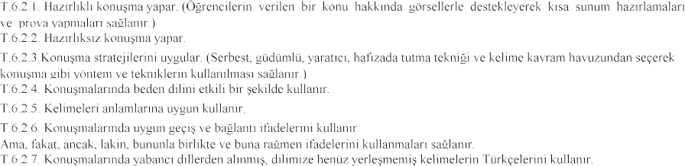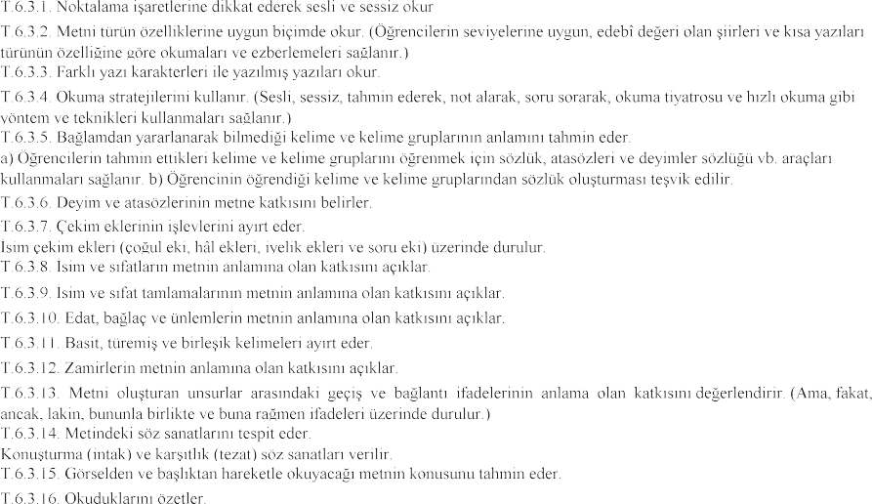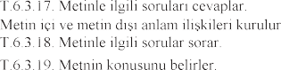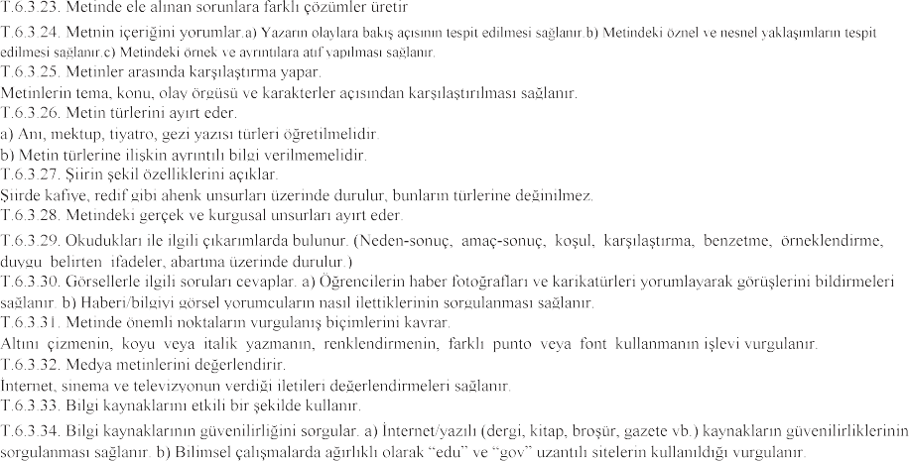**TÜRKÇE DERSİ 6. SINIF YILDIRIM YAYINLARI KONU SORU DAĞILIMI TABLOSU**

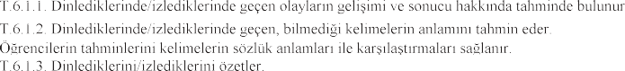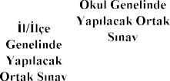

|  |  |  |  |  |  |
| --- | --- | --- | --- | --- | --- |
| P818C1T5#yIS1 | P820C2T5#yIS1 | P824C3T5#yIS1 | 2. SINAV | | |
|  |  | |
| **1.Senaryo** | **2.Senaryo** |
| P845C9T5#yIS1 | P849C10T5#yIS1 |  |  |  |  |
| * | * | * |
|  | * | * | * |
|  | * | * | * |
| * | * | * |
|  | * | * | * |
| * | * | * |
|  |  |  |  |
|  |  |  |  |
|  |  |  |  |
|  | * | * | * |
|  | * | * | * |
|  | | | | | |
| P935C60T5#yIS1 | P937C61T5#yIS1 |  | * | * | * |
|  | * | * | * |
|  | * | * | * |
|  | * | * | * |
|  | * | * | * |
|  | * | * | * |
|  |  |  |  |
| **T.6.3. OKUMA** | P987C91T5#yIS1 |  | * | * | * |
|  | * | * | * |
|  |  |  |  |
|  | * | * | * |
| P1019C108T5#yIS1 |  | 1 | 1 | 1 |
|  | 1 | 1 |  |
|  | 2 | 1 | 1 |
|  |  |  |  |
|  |  |  |  |
|  |  |  |  |
|  |  |  |  |
|  |  |  |  |
|  | 1 | 1 | 1 |
| P1092C145T5#yIS1 |  | 1 | 1 | 1 |
|  |  |  |  |
|  |  |  |  |
|  | 3 | 1 | 1 |
|  |  |  |
|  | 1 | 1 |  |
|  | 2 | 1 | 1 |
|  |  |  |
|  | 1 | 1 | 1 |
|  |  |  |  |
| 1 |  |  |
|  | 1 |  |  |
|  | 1 | 1 | 1 |
|  |  |  |  |
|  |  |  |  |
| **T.6.3. OKUMA** | P1200C207T5#yIS1 |  | 1 | 1 | 1 |
|  |  |  |  |
|  |  |  |  |
|  |  |  |  |
|  |  |  |  |
|  |  |  |  |
| P1244C232T5#yIS1 |  |  |  |
|  | | | | | |

|  |  |  |  |  |  |
| --- | --- | --- | --- | --- | --- |
|  | P1273C2T6#yIS1 |  |  |  |  |
|  |  |  |
|  |  |  |  |
|  |  | 1 |  |
|  |  |  |  |
|  |  |  |  |
|  | 1 |  |  |
|  |  |  |  |
|  |  |  |  |
|  | 2 |  |  |
|  |  |  |  |
|  |  |  |  |
|  |  |  |  |
|  |  |  |  |
| P1371C59T6#yIS1 | | | **20** | **12** | **9** |

